Michael Peterson CHP4

4-10
@@@@@
@@@@@
@@@@@
@@@@@
@@@@@
@@@@@
@@@@@
@@@@@
@@@@@
@@@@@

4-17
a) true
b) false
c) true
d) false
e) false
f) false
g) false
4-17
Program
import java.util.Scanner;
public class smallest { // should be sales named it wrong
public static void main (String[] arg) {
Scanner input = new Scanner(System.in);
double prod1 = 2.98, prod2 = 4.5, prod3 = 9.98, prod4 = 4.49, prod5 = 6.87,
end1=0, end2=0,end3=0, end4=0, end5=0;
int quan1 = 0, quan2 =0, quan3=0, quan4 =0, quan5=0, sale =0, end = 1, vol=0;
while (end == 1)
{
System.out.print("Enter a product number and number sold, seperate with a space1");
sale = input.nextInt();
vol = input.nextInt();
//System.out.println(vol); test if it got each int
switch (sale){
case 1:
quan1+=vol;
break;
case 2:
quan2+=vol;
break;
case 3:
quan3+=vol;
break;
case 4:
quan4+=vol;
break;
case 5:
quan5+=vol;
break;
default:
System.out.println("We do not sell that item please try again.");
break;
}
vol = 0;
sale=0;
System.out.print("Do you want to go again (1 for yes, 2 for no)?");
end = input.nextInt(); // why is nextChar() not working?
}
end1 = quan1*prod1;
end2 = quan2*prod2;
end3 = quan3*prod3;
end4 = quan4*prod4;
end5 = quan5*prod5;
System.out.printf("%s%.2f%n%s%.2f%n%s%.2f%n%s%.2f%n%s%.2f%n", "Finale sales for item 1 is ", end1, "Finale sales for item 2 is ", end2,
"Finale sales for item 3 is ", end3,"Finale sales for item 4 is ", end4, "Finale sales for item 5 is ", end5);
}
}
Run throu: (selling 2 of item 1; 1 of item
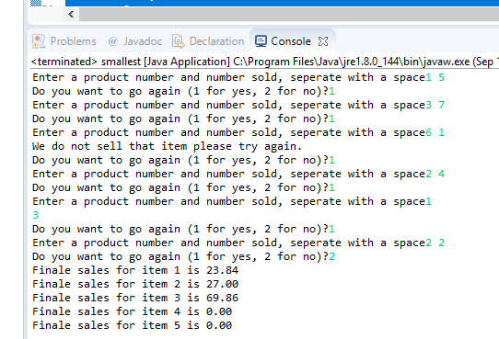
Note that not product 4 or 5 were sold, and when product 6 entered it gave back not being sold. End sales of 8 item 1s, 7 items 3s, and 4 item 2s.
4.11
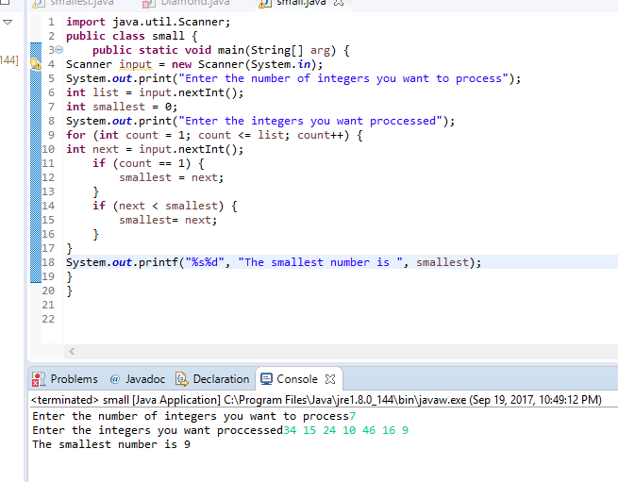
4.24
Program
public class Diamond {
public static void main(String[] arg) {
for (int line = 1; line <= 9; line++) {
if (line == 1 || line == 9) {
for (int num=1; num <=4; num++) {
System.out.print(" ");
}
System.out.print("*");
System.out.println();
}
if (line ==2 || line ==8) {
for (int num=1; num <=3; num++) {
System.out.print(" ");
}
for (int num =1; num <= 3; num++) {
System.out.print("*");
}
System.out.println();
}
if (line == 3 || line == 7) {
for (int num=1; num <=2; num++) {
System.out.print(" ");
}
for (int num =1; num <= 5; num++) {
System.out.print("*");
}
System.out.println();
}
if (line == 4 || line == 6) {
System.out.print(" ");
for (int num =1; num <= 7; num++) {
System.out.print("*");
}
System.out.println();
}
if (line == 5) {
for (int num =1; num <= 9; num++) {
System.out.print("*");
}
System.out.println();
}
}
}
}
Does: 